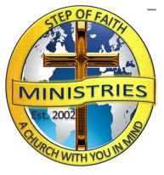
Another Step
Step of Faith Ministries Newsletter
a cHURCH wITH YOU IN MIND
R.J. Thornton Founder and Pastor May 2018
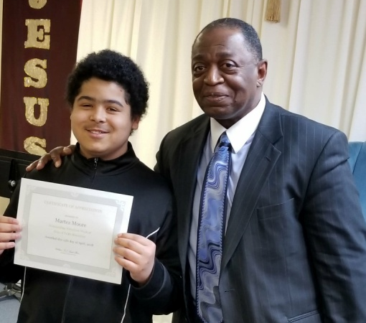
Proverbs 22:6 Train up a child in the way he should go: even when he is old he will nor depart from it.
Martez Moore was recognized for his Faithful service to the Church. Martez first started attending Step of Faith at the in 2008 at the age of 4. He has stated that, “Even when I’m an adult I plan to still come to church!”

Is Your Plate Full
From the desk of First Lady Thornton
Is Jesus your afterthought? We can fill our plate with layers that we become so full that we leave no room for Jesus. When you become so full, you can easily suffer. Suffering is never a good feeling and I’d rather deny myself than to suffer. I don’t need anybody or anything more than I need Jesus. Without Jesus I have absolutely no chance of making It into Heaven. Acts 4:12 there is no other name under heaven and earth on which we can be saved. Why would I take a chance of not making room for Jesus? Sometimes we overschedule ourselves but if you allow yourself to prioritize Jesus before your plate becomes full, he doesn’t have to be an afterthought. First, you have to WASH your plate. When you give your life to the Lord, you are clean. You are a new person. Second, you have the WORD. John 1:14 The Word became flesh and made his dwelling among us. We have seen his glory, the glory of the one and only Son, who came from the Father, full of grace and truth. The next layer is FAITH. Romans 10: 17 Faith comes by hearing and hearing by the word of God. In between the layers, add a little praise. What’s your plate looking like?

Congratulations to our 2018 Graduates on all of your hard work and determination.
This Photo by Unknown Author is licensed under CC BY-SA

Don’t Refuse the Instructions From The Desk of Pastor Thornton
Many times things do not work out because people don’t pay any attention to God’s instructions (Exodus 23: 20-25). God speaks to us through people, places and things. You don’t only grow in God when great things happen in life. We grow in God when we suffer great thing. God sends help and assistance but you must humble yourself in order to receive it.
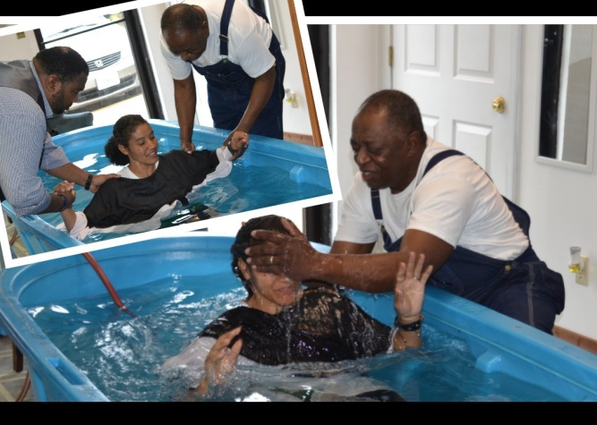
Step of Faith Baptism, April 22nd 2018 Baptized Left to Right were Pam Maurer, Kim Hildebrand and Erica Montgomery

Romans 6:4 Therefore we are buried with him by baptism into death; that like as Christ was raised up from the dead by the glory of the Father, even so we also should walk in the newness of life.
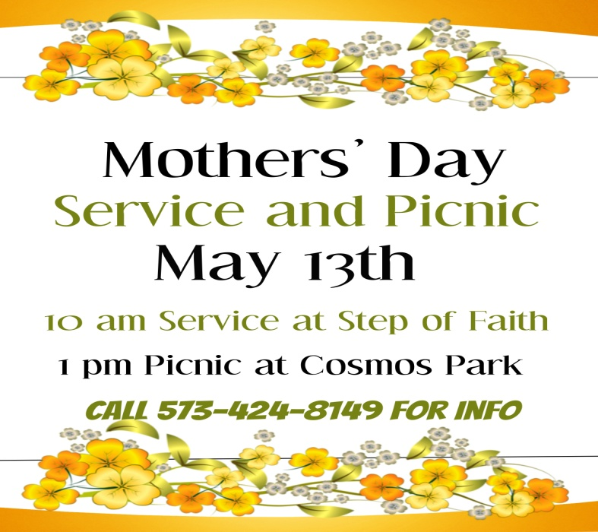
To All May Birthdays
Church statistics show that 47% of unchurched Americans are open to thinking about a new church based on a friend’s invite. This shouldn’t be too surprising considering the social networking age. Consider not only word-of-mouth but social networking as a way to boost attendanceFrom ReachRight.com

_____Faith Without Works Is Dead
Learning to live the life
Sunday School
Sunday Mornings at 9am
Sunday School Needs You!

Bible Study
Wednesday at 7pm
“A Class for Every Age”

Sign up for Step of Faith Text Alerts
Text EZKLK56267 to 31313

Bible Study
Wednesday @ 7pm

